Munters Provides Dry Air to Preserve Valuable Books
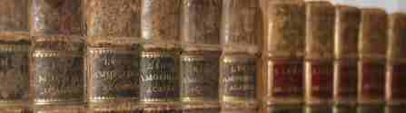
A Munters dehumidification system supplies precisely conditioned air into two archive rooms in the basement of the public library in Växjö, Sweden. These rooms house important replicas and original works of the world famous Swedish botanist Carl von Linné.
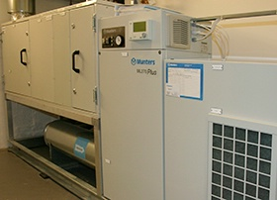
Carl von Linné is the father of modern taxonomy. He laid the foundations for the modern scheme of binominal nomenclature. During studies in Sweden and abroad he collected and classified plants, animals and minerals, publishing the first edition of the important work Systema Naturae in 1738.
In Växjö, where Linné went to school, the public library is now exhibits part of his most important works. An important collection of his books and a genuine diary are some of the articles archived in the basement.
Munters was selected because the two rooms are secured and needed to be conditioned in accordance with the recommendations from the National Archives of Sweden, keeping a temperature at 64°F (± 2°) and a relative humidity of 30-40% RH (± 5%) year round. At these conditions the irreplaceable books would be protected against the damages related to high and fluctuating humidity, that has already been aggressive to the more than 200 year old fragile paper documents and the books' leather bindings.
In addition to the Munters system's desiccant rotor providing dehumidification, the unit contains a post cooler, post heater and a humidifier for cold winter days. The Munters unit is creating the optimal climate for delicate artifacts that can now be protected for years to come without further deterioration.
Munters will provide the following benefits for the archive:
- Optimal storage climate for fragile paper documents
- Constant climate around the year
- No deterioration of historical books and documents
- Only one unit for both dehumidification and humidification
- Small foot-print compared to conventional solutions
For more information email dhinfo@munters.com.

